Best Wear for Everyday Wear (2026 Style Guide)
By Sugandh Gupta | September 10, 2026
Real talk, most of what’s just hanging in your closet wasn’t bought for a wedding, or some huge night out. It was bought for those, sort of boring hundred ordinary days in between you know, the ones where nothing “special” is happening. So yeah, best wear for everyday wear kinda matters more than people admit. A women's daily wear dress has to get you through errands, work calls, last minute plans… and still look okay by evening, without you stressing about it or adjusting everything every ten minutes.
This little guide is basically for the best wear for everyday wear you’ll actually grab-cotton kurta sets, co-ord sets, easy one-piece dresses, all that-plus some fabric notes, styling ideas, and a few honest tips so you’re not just guessing.

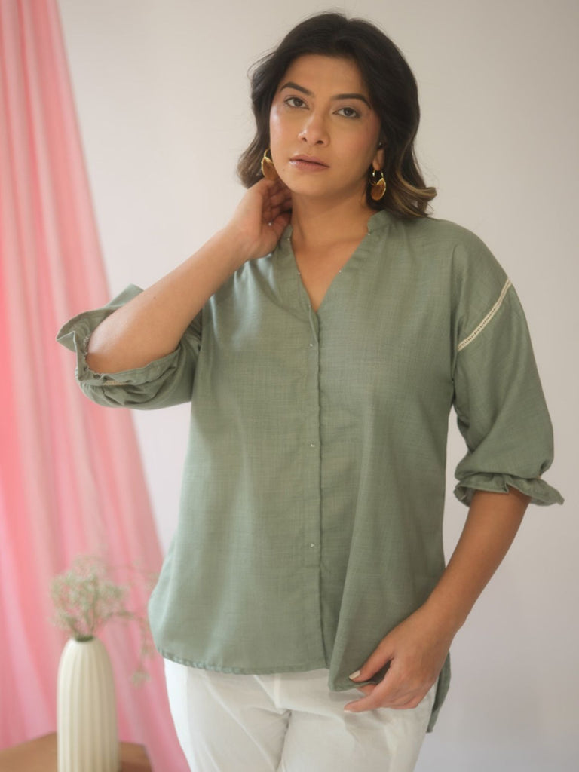
Why everyday wear kinda deserves its own rules
Occasion wear is made to impress for a few hours, and then it can chill. Best wear for everyday wear is more like, it has to be lived in, which is a whole different assignment. It needs to survive a full workday plus maybe a quick market run, without constant fixing, or an iron that shows up every morning like it pays rent.
A solid women's daily wear dress usually boils down to breathable fabric, room to move, and a shape that looks intentional even when you didn’t “try” too hard. The goal isn’t to look overly dressed up—more like put-together, on a regular, totally ordinary day, with that effortless vibe people pretend is easy.

Types of women's daily wear dress worth having
Everyday wardrobes work way better when you keep a small rotation of dependable pieces, not just one dress you repeat until it fades. Here’s what’s actually worth keeping around.
Cotton kurta sets, for that comfort thing
A well-cut cotton kurta set is still one of the most reliable forms of best wear for everyday wear. It’s breathable, easy to layer, and “polished enough” for a video call or a quick outing. It’s a daily go-to because you need almost zero extra styling to look finished.
Co-ord sets, for that put-together shortcut
Matching co-ord sets have basically turned into the go-to women's daily wear dress alternative, because top and bottom are already handled for you. A linen or cotton-blend co-ord feels a bit tailored, without that stiff, uncomfortable energy. It works for both home days and casual outings-same set, different mood.
Everyday dresses and one-pieces
If you want the fastest way to get dressed, pick a simple one-piece dress in something soft and breathable. Really, skip the coordinating, skip the overthinking, and you’ve still got a full women’s daily wear dress look in under a minute.
Tops and shirts you can mix around
Well-fitted tops in soft cotton or tussar-silk blends help round out the best wear for everyday wear rotation. Pair with jeans, trousers, or a simple skirt, and suddenly the outfit feels new again, even when you didn’t actually buy anything-also kind of the point.

Choosing best wear for everyday wear based on what’s happening
Not every day looks the same, so your outfit shouldn’t be the exact same formula either. Here’s a simple way to match it.
Home and work-from-home days
For days mostly at home, or stuck on video calls, soft cotton kurta sets or a relaxed co-ord set are usually the best wear for everyday wear. Comfortable for sitting around, but still neat enough to look decent on camera from the waist up, at least.
Errands and city running-around
Running errands means walking, sitting in traffic, random stops, and generally, life happening. A women's daily wear dress or kurta set that handles that without wrinkling too aggressively is the move. Cotton and linen blends usually hold up best, especially once it gets warm.
Casual outings and coffee dates
For a casual outing or a spontaneous coffee thing, the same everyday dress or kurta set can be dressed up fast. Swap flats for wedges, grab a slightly nicer bag, and boom-day errands to evening-ready, without changing clothes.

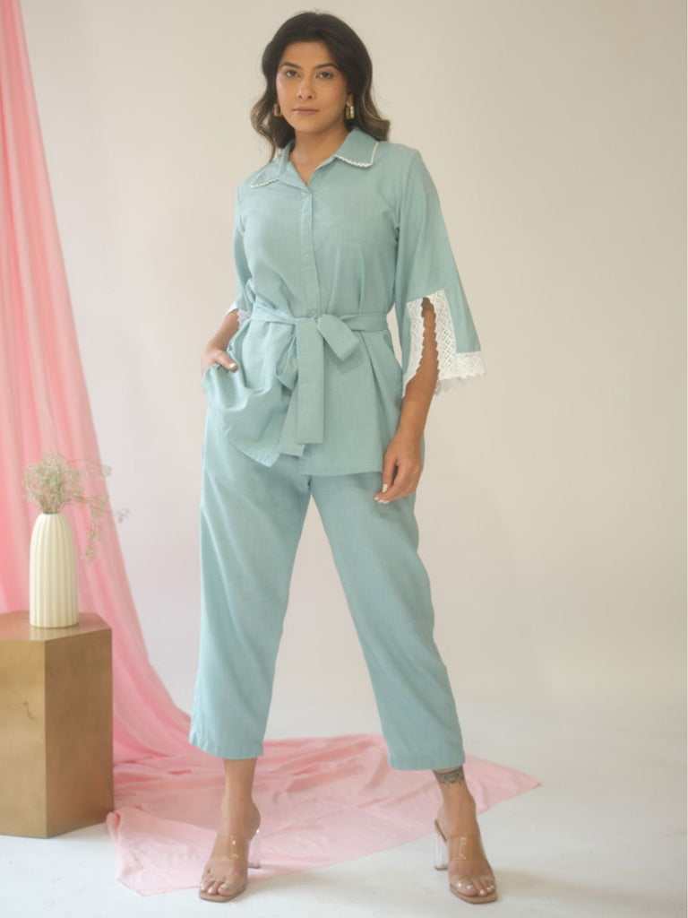
A quick fabric guide for daily wear
The fabric you pick decides how comfortable, and how low-maintenance, your everyday wear ends up being.
● Pure cotton-breathable, soft, great for hot or humid days, and usually nicer for sensitive skin.
● Linen and linen blends-lightweight, natural texture, creases quickly but somehow still looks “intentional.”
● Cotton-crepe blends-drapes well, resists wrinkling, a solid middle ground for busy days.
● Tussar-silk blends-adds that subtle sheen, especially for tops that need to shift from daytime to casual evening.
And when you’re not sure, lean toward fabrics with at least some cotton in them. They breathe better through a full day than fully synthetic options, especially with India’s kind of climate.

How to actually style best wear for everyday wear
● Keep jewelry minimal on busy days-studs and a thin chain is honestly plenty.
● Layer a light jacket or shrug over a kurta set on cooler mornings, then take it off once the day warms up.
● Choose flats or comfortable block heels on days with lots of walking.
● Stick to two or three go-to hairstyles that take under five minutes, so mornings don’t stretch into chaos.
One more thing, lay out your outfit the night before, especially on genuinely busy weekdays. It removes a surprising amount of decision fatigue. Suddenly your best wear for everyday wear choices feel automatic instead of turning into some debate every morning.

Building a small capsule wardrobe for daily wear
You don’t need dozens of choices lying around. You need a small set of pieces that actually match with each other. Two or three kurta sets, a couple of co-ord sets, one or two easy dresses, plus a handful of tops covers most weeks without repeating the exact same look, more or less.
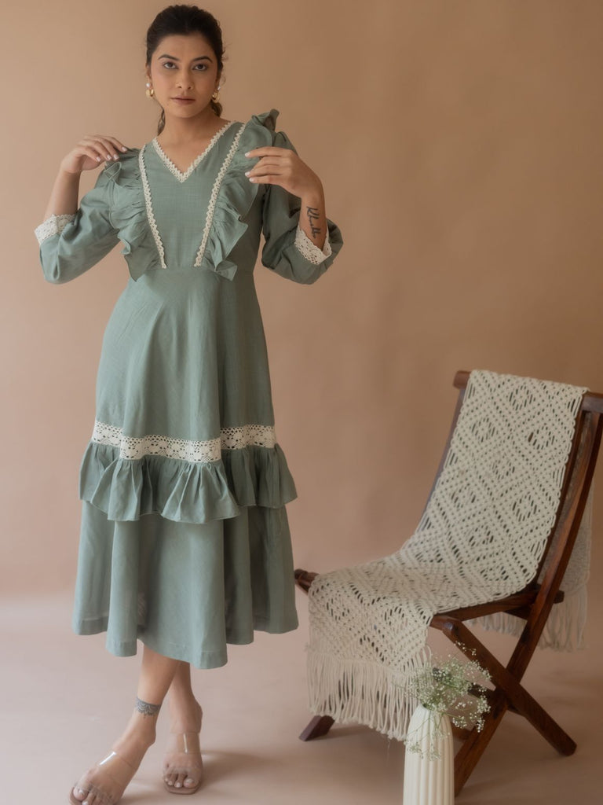
Taking care of your everyday pieces
Honestly, since everyday clothes get worn and washed way more often than occasion wear, a little extra care… it sort of goes a long way, even if you’re busy, or whatever.
● Wash in cold water with a mild detergent, to help protect color and the fabric’s structure
● Line dry in the shade instead of direct sun, so those frequently worn pieces don’t fade fast
● Iron on medium-high while the fabric’s still a little damp, for that crisp finished vibe
Oh, and if it’s a printed or embroidered piece, turn it inside out before washing, this helps guard the print and the stitching from all that friction over repeated washes

Frequently Asked Questions
What actually makes something count as “best wear” for everyday wear?
Mostly it’s breathable fabric, easy movement, and low maintenance, not heavy embellishment. It should still look put together without needing a ton of styling effort, like at all
Can a women's daily wear dress also work for a casual outing?
Pretty much yes. Most everyday dresses and kurta sets transition easily enough—swap the flats, add a nicer bag, or some statement earrings, and suddenly it works for a casual evening too.
Which fabric handles hot, humid weather best?
Pure cotton and linen blends, generally. They breathe better and deal with moisture better than most synthetic fabrics, especially if it’s tropical weather happening.

How many everyday outfits do you really need?
A small capsule of about six to eight pieces, like a few kurta sets, a couple of co-ord sets, one or two dresses, some tops. That usually covers a full week without you repeating the same look twice, which is kinda the goal.

Final Thoughts
Finding the best wear for everyday wear isn’t really about buying more. It’s more about choosing a small group of comfortable, breathable pieces that actually work together. A good women's daily wear dress, a couple of kurta sets, one reliable co-ord set-yeah that’s usually enough to get through most ordinary days without the “what do I wear now” stress.
Go ahead and explore the full everyday wear collection, curated by World of Sugandh, to build a daily wardrobe that feels comfortable, but still looks put-together. And if you already have something in mind, check out cotton kurta sets or co-ord sets under ₹2000 for a quicker pick

About the Author
Sugandh's a fashion writer who’s been doing this for over 8 years, mainly around Indian ethnic and everyday wear-comfortable, wearable, daily styling is kind of the whole focus. Read more on the About Us page, or follow along on Instagram and YouTube

