Women Kurta Set Guide: Styles, Fabrics & Styling Tips
By Sugandh Gupta | September 12, 2026
If you ask any Indian woman what one outfit she keeps coming back to, it’s usually a women kurta set. Like, seriously it’s one of those rare looks that can move from a work-from-home morning to a festive night, and you don’t feel like you need a totally new wardrobe every single time. That’s also kinda why the right kurta set women end up wearing way more than anything else that’s just sitting there in the closet.
In this guide, we’ll cover almost everything you’d wanna know before buying a women kurta set - the types, what fabrics actually work for different plans, how to pick the right fit, and yep, a pro tip under each part so you can shop a bit smarter, instead of guessing on the fly.
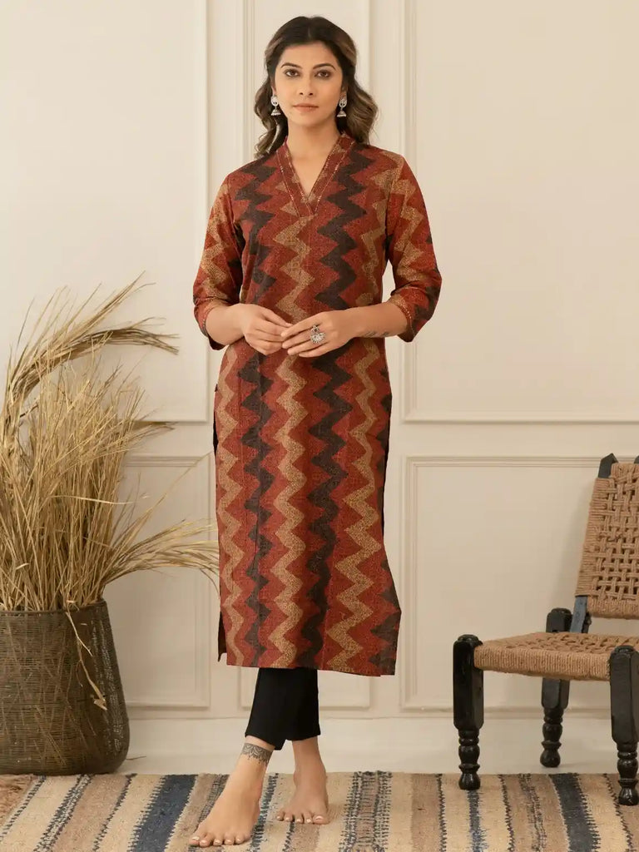
Why a Women Kurta Set Belongs in Every Wardrobe
A women kurta set that’s well-made solves a problem most other outfits don’t even try to handle. It looks sorted, without you having to do much at all. The top and bottom are already matched, the silhouette usually flatters a bunch of body shapes , and you can dress it up or tone it down depending on the day. No real drama.
Also, the kurta set women invest in tends to outlast fast-fashion trends. Classic cuts, natural fabrics, and clean detailing don’t go out of style the way trend-only pieces do. They just keep getting reshuffled, season after season, with new styling ideas.
Pro Tip: If you’re buying your first few kurta sets, start with solid colors like maroon, teal, or mustard… before you jump into prints. Solids are easier to accessorize with, and you can rewear them across occasions without that “oh no, will this work?” feeling.

Types of Women Kurta Set to Know
Not every kurta set is built for the same kind of moment. Here’s a quick way to see how the main categories usually differ.
Everyday Cotton and Cotton-Crepe Kurta Sets
For regular, day-to-day wear, a cotton or cotton-crepe women kurta set is honestly the safe option. It’s breathable, easy to move around in, and it forgives you when life is busy, like it still looks fine by night even if you wore it all day. This is the kurta set women reach for for work-from-home days, quick errands, and casual catch-ups.
Pro Tip: Choose cotton-crepe instead of plain cotton if you want a set that stays tidy through a full schedule. It keeps its shape better, even when everything else is moving fast.

Office-Ready Kurta Sets
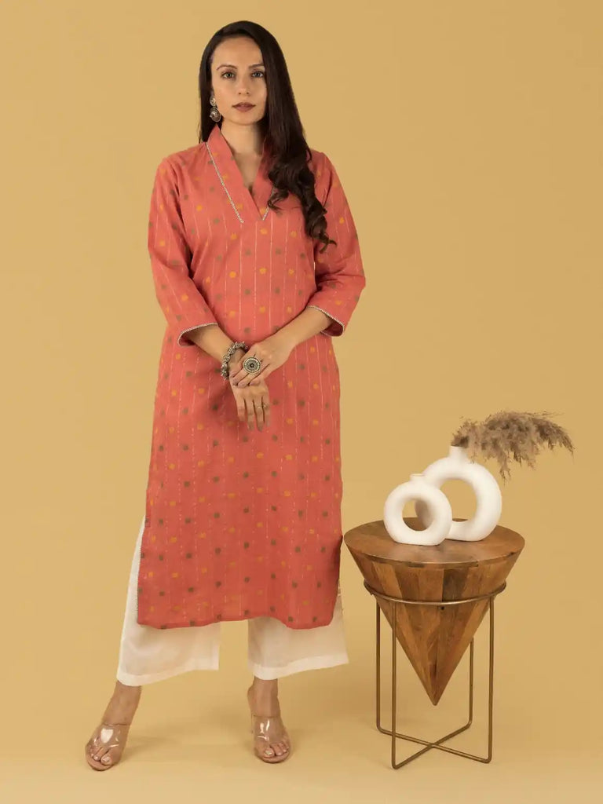
An office-ready women kurta set usually leans into a more structured look, think cotton-crepe with a clean silhouette. It works when your office wants you to look polished, but not overly formal. The fabric naturally resists creasing, so the kurta stays neat from morning meetings to evening plans.
Pro Tip: Wear an office-ready kurta set with minimal gold jewelry, plus a structured tote. The whole thing reads put-together, not overdressed for workplace rules.

Festive Silk Kurta Sets
For Diwali, Eid, or any family celebration, a silk women kurta set brings the richer texture and subtle shine those moments kinda ask for. With hand-finished embroidery and zari work, even a simple cut starts giving dress-up vibes.
Pro Tip: Go for a statement dupatta instead of stacking heavy jewelry when you wear a festive silk kurta set. The look stays celebratory, without competing with the fabric detailing it already has. And it just looks more intentional.

Wedding-Guest Kurta Sets
If you’re attending a wedding, you want your women kurta set to feel festive but not steal the spotlight from the couple. Georgette and silk-blend kurta sets, with delicate surface work, usually hit that sweet spot: celebratory, refined, and totally workable for multi-day wedding schedules.
Pro Tip: Pack one georgette kurta set that can handle two functions. You just swap the dupatta drape and the jewelry, and suddenly it feels like a fresh outfit instead of repeat-wear.

Choosing the Right Fabric for Your Women Kurta Set
Fabric changes the whole vibe, not just how it looks in pictures.
● Cotton: Breathable, soft, best for everyday wear and warmer climates.
● Cotton-Crepe: Structured but still flows, resists creasing, great for daily and office wear.
● Silk: Luxurious texture with that natural glow, ideal for festive plans or celebratory evenings.
● Georgette: Light, fluid, gives easy movement… perfect for wedding and evening wear.
Pro Tip: If you’re buying just one silk kurta set, choose a deep jewel tone like maroon or emerald. It looks amazing in daylight photos, and it also flatters in evening lighting, without looking dull.

How to Choose the Right Fit and Size
A women kurta set should skim your body, not cling. The silhouette is meant to flatter through gentle structure, not tight tailoring. Always check the size chart on the product page too, because cut and proportions can shift a little between styles.
● A-line and straight-cut kurta sets tend to flatter many body types with minimal tweaks.
● Petite frames often look best with shorter kurta lengths, paired with straight or slim-fit bottoms.
● Fuller figures are usually flattered by structured cotton-crepe, over very lightweight clingy fabrics.
Pro Tip: If you’re between two sizes, choose the bigger one instead of sizing down. It’s so much easier to take in a loose fit using a belt, or even adjusting with dupatta drape, rather than feeling restricted in something too tight.

Styling a Women Kurta Set for Different Occasions
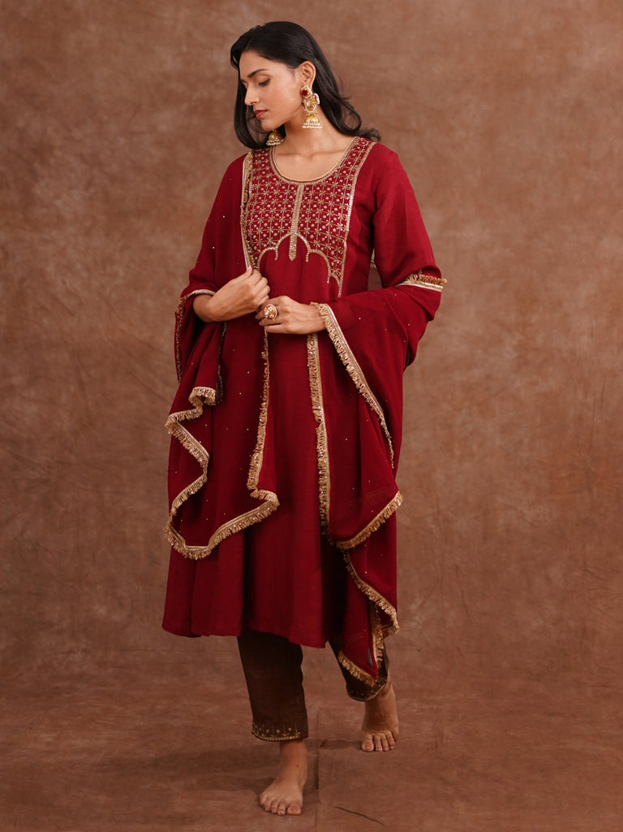
● For daytime festive vibes: keep jewelry minimal like pearls, go for soft makeup, finish with comfortable flats.
● For evening functions: switch to statement Polki jewelry, do a sleek updo, and pair with metallic heels for a sharper finish.
● Layer a contrasting dupatta over a solid kurta set to add dimension, without buying a completely new outfit.
● Add kolhapuris or block-heeled sandals to make the look feel more relaxed for daytime.
Pro Tip: Keep one neutral kurta set in your closet that you can restyle from day to night. Just change the dupatta drape and jewelry, and it saves money AND space, which is honestly the best kind of win.

Caring For Your Women Kurta Set
Caring for women kurta set stuff , especially the handcrafted and embellished kind… yeah it needs that little bit extra attention, not fully dramatic, but sort of sensitive over time. They look so nice though , just , treat them gently, ok
● Store heavily embroidered kurta sets in breathable muslin bags instead of plastic covers, so you avoid moisture damage later on, you know how that goes
● Fold embellished pieces, don’t hang them , because the weight of handwork can slowly pull at delicate fabric if you leave it that way for too long
● Dry clean silk and zari-detailed kurta sets, this protects both the embroidery and that natural fabric shine, it stays nicer
Pro Tip: Turn a printed or embroidered kurta set inside out before you wash it at home. It kind of shields the surface detailing from friction too, in the wash

Frequently Asked Questions
What makes a women kurta set different from a regular kurti?
A women kurta set usually shows up with matching or coordinated bottoms and often a dupatta, it’s basically designed like a whole outfit. A kurti is, most of the time, sold and styled as a standalone top

Can the same kurta set work for both office and festive occasions?
Yes, totally, if you go for something more versatile like a solid-color cotton crepe kurta set. Keep jewelry on the minimal side for office, then switch to a statement dupatta plus heavier jewelry later for a festive evening, easy

Which fabric is best for a first-time kurta set buyer?
Cotton or cotton-crepe is the safest first pick. Breathable, low-maintenance, and flexible enough for daily wear, even for those light festive moments

How many kurta sets should I own?
For a starter wardrobe, you could go with two to three everyday cotton kurta sets, one office-ready set, and one festive silk or georgette kurta set for celebrations

Final Thoughts
Honestly, a well-chosen women kurta set feels like one of those wardrobe investments that just keeps showing up for you. It goes from daily wear into festive nights with basically just a styling change. Whether you’re making your first capsule, or you’re looking for a festive kurta set women can dress up for weddings, the right fabric and fit really do the heavy lifting
Don’t miss the full handcrafted kurta sets collection, curated by World of Sugandh, to find pieces made with that careful attention, whether you want everyday comfort or festive celebration vibes. You can also browse specific edits like cotton kurta sets or silk kurta sets, if you already have a clear idea what you want

About the Author
Sugandh is a passionate fashion writer with more than 8 years of experience in Indian ethnic wear. Her focus is on handcrafted kurta sets and festive styling. For more, read on the About Us page, or follow along on Instagram and YouTube

